How to conduct a Fisher's exact test in Cytel Studio
Chong Ho Yu, Ph.D.
http://www.creative-wisdom.com
chonghoyu@gmail.com
December 28, 2010
The objective of this write-up is to illustrate the procedure of running a Fisher's exact test as a supplement to a conventional Pearson's Chi-square test. For the conceptual framework of exact tests, please consult:
Yu, C. H. (2003). Resampling methods: Concepts, applications, and justification. Practical Assessment Research and Evaluation, 8(19). Retrieved from http://pareonline.net/getvn.asp?v=8&n=19
Yu, C. H. (2007). Resampling: A conceptual and procedural introduction. In Jason Osborne (Ed.), Best practices in quantitative methods (pp. 283-298). Thousand Oaks, CA: Sage Publications.
Steps
In Cytel Studio, choose New from the pull down menu File. Next, select Table Data and then click OK.
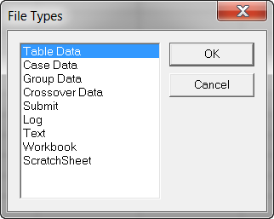
In this example, we will use two categorical variables, and each variable has two categories. Thus, we will use a 2-colum X 2-row table.
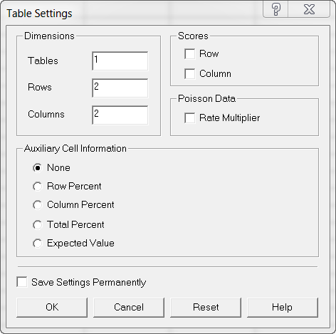
In this hypothetical data set, there are 48 male students and 42 female students. Some of them are majoring in science while some are majoring in art. We want to know whether gender makes a difference in choosing a major. It could be not the otherwise. Choosing an art major cannot make me a girl. In this step, we can simply enter the labels and the data as follows:
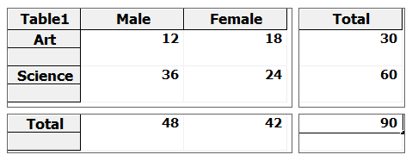
Next, from the pull down menu Nonparametrics, scroll down to Unordered R X C Table. Three options will pop up. Although the goal is to perform a Fisher's exact test, you can run a Pearson's Chi-square test first to obtain the Chi-square value.
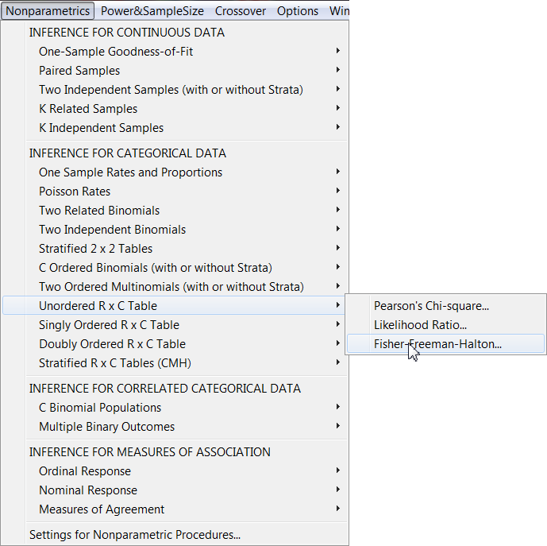

Another window will prompt you to choose an inference method. You can select any one of the options. With such a small sample size, Cytel Studio will yield both asymptotic and exact p values by default.
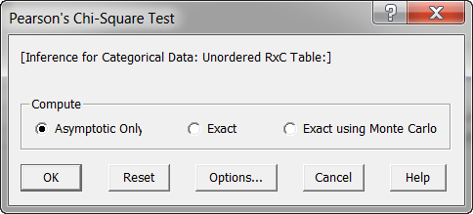
The Chi-square test shows you the p values, the Pearson Chi-square statistics and the Chi-square with Yates CC.
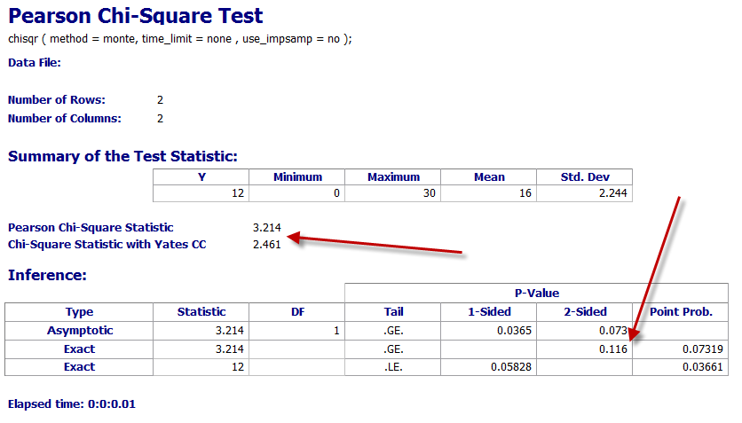
Next, run a Fisher's exact test. Again, you have three options. With a small data set, you can select the Exact option, which will use all possible permutations. However, when you have a large data set, it could be very computing-intensive and time-consuming. It is better to choose Exact using Monte Carlo by default. In this option, a subset of all possible permutations will be simulated.
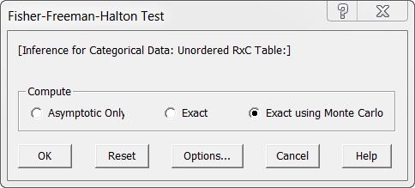
In this example, you can see that the statistics of the Fisher's exact test is slightly different from that of the Pearson's Chi-square test. Using a two-sided test, both test concur that there is no gender effect in major selection.
